Q1. Create a vehicle class with an init method having instance variables as name_of_vehicle, max_speed and average_of_vehicle.

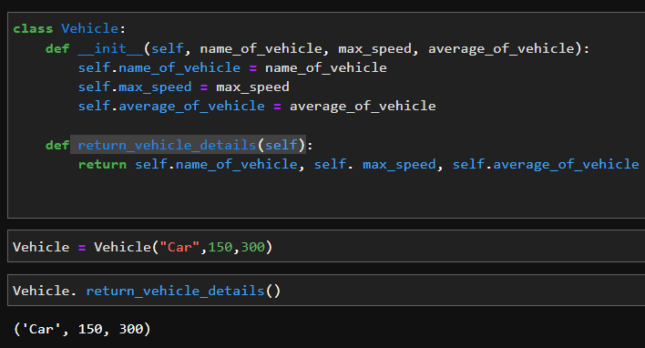

Q2. Create a child class car from the vehicle class created in Que 1, which will inherit the vehicle class.

Create a method named seating_capacity which takes capacity as an argument and returns the name of the vehicle and its seating capacity.

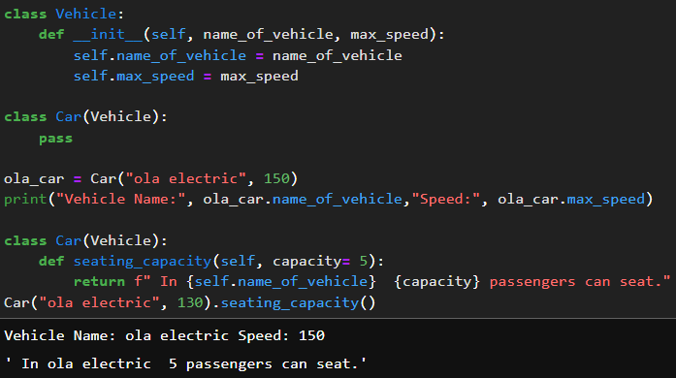

Q3. What is multiple inheritance? Write a python code to demonstrate multiple inheritance.

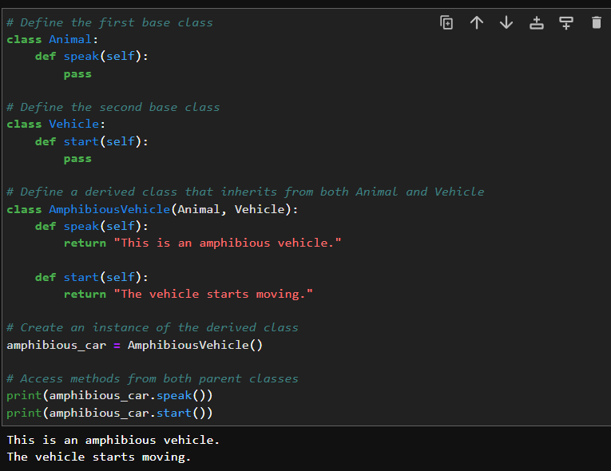

Q4. What are getter and setter in python? Create a class and create a getter and a setter method in this class.

-Getters and setters are methods used to access and modify the attributes (instance variables) of a class in a controlled way. They are often used to enforce encapsulation and provide a mechanism for controlling access to class attributes, allowing you to add validation or custom logic when getting or setting values. Conventionally, Python uses property methods to create getters and setters.

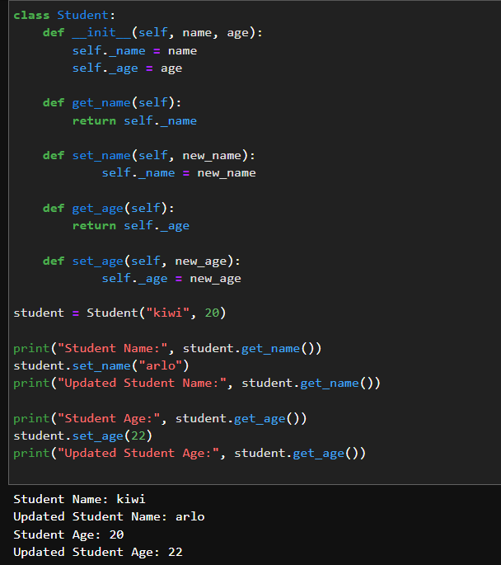

Q5. What is method overriding in python? Write a python code to demonstrate method overriding.

Method overriding is a feature in object-oriented programming (OOP) that allows a subclass to provide a specific implementation of a method that is already defined in its parent class. When a subclass overrides a method, it provides a new implementation for that method while keeping the method's name and parameters the same. The overridden method in the subclass is then used instead of the method in the parent class when called on an instance of the subclass.

